**RETAIL SALES ANALYSIS**

**Group 06:** Roshan Rawat, Gangothri Gadige, Chandan Kumar, Narendra Reddy, Faryar Memon

### Create multiple users to work under the same resource group

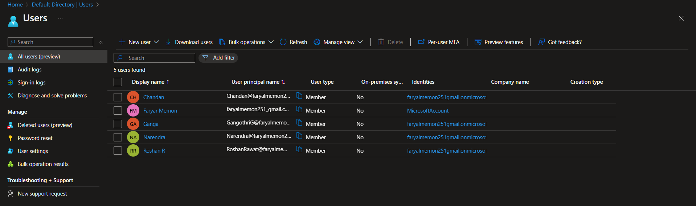

**Give privileges to the users in Resource Group and Subscriptions**

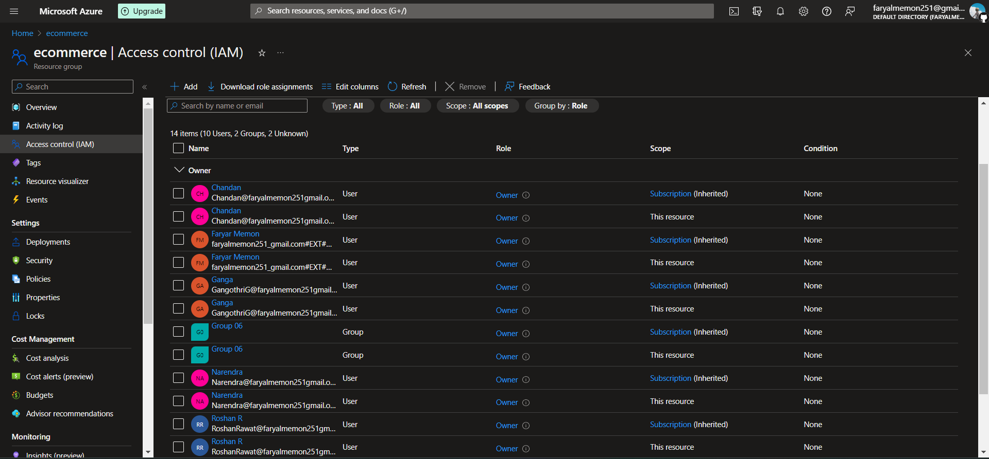

### Create Storage Account and Database

## Client Source Azure SQL Database config

create table retail(region varchar(1000), country varchar(1000), item_type varchar(1000), sales_channel varchar(1000), order_priority varchar(1000), order_date varchar(2000), order_id int, ship_date varchar(1000), units_sold int, unit_price float, unit_cost float, total_revenue float, total_cost float, total_profit float)

CREATE MASTER KEY ENCRYPTION BY PASSWORD ='Roshan@3003'

create database scoped credential MyAzureBlobStorageCredential

WITH IDENTITY ='SHARED ACCESS SIGNATURE',

SECRET = ‘<SAS token>’

CREATE EXTERNAL DATA SOURCE MyAzureBlobStorage

WITH ( TYPE =BLOB_STORAGE,

LOCATION = 'https://ecomfiles1.blob.core.windows.net/csvfiles/',

credential = MyAzureBlobStorageCredential)

BULK INSERT dbo.retail from 'sales_data.csv'

with (check_constraints,

DATA_SOURCE = 'MyAzureBlobStorage',

datafiletype ='char',

fieldterminator =',',

rowterminator='0x0a',

firstrow=2,

keepidentity,

tablock)

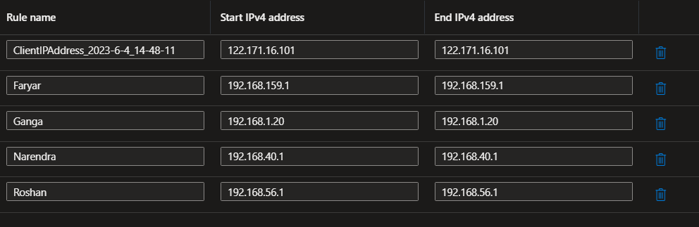

Faryar 192.168.159.1

Ganga 192.168.1.20

Narendra 192.168.40.1

Roshan 192.168.56.1

Chandan 192.168.187.1

## Transferring Data from Client Source (Azure SQL Database) to ADLS using ADF

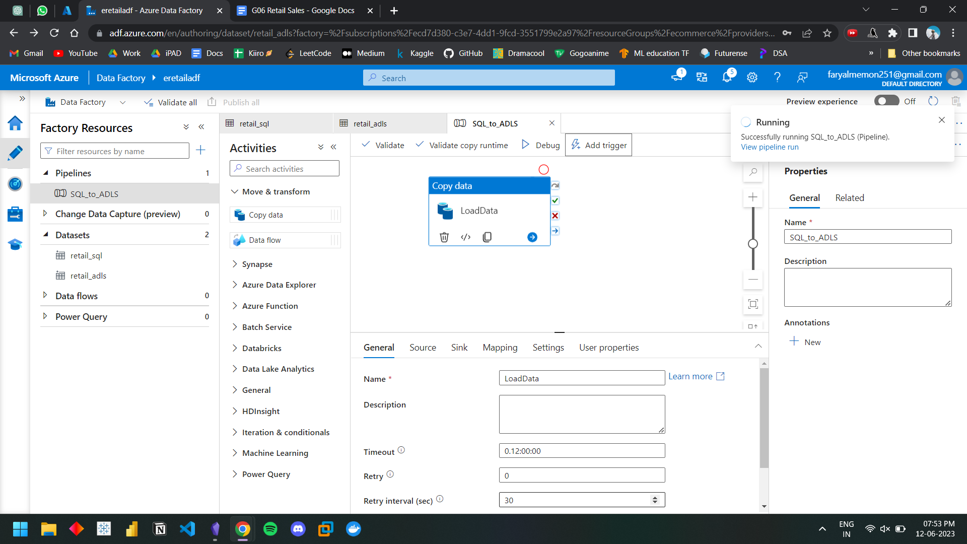

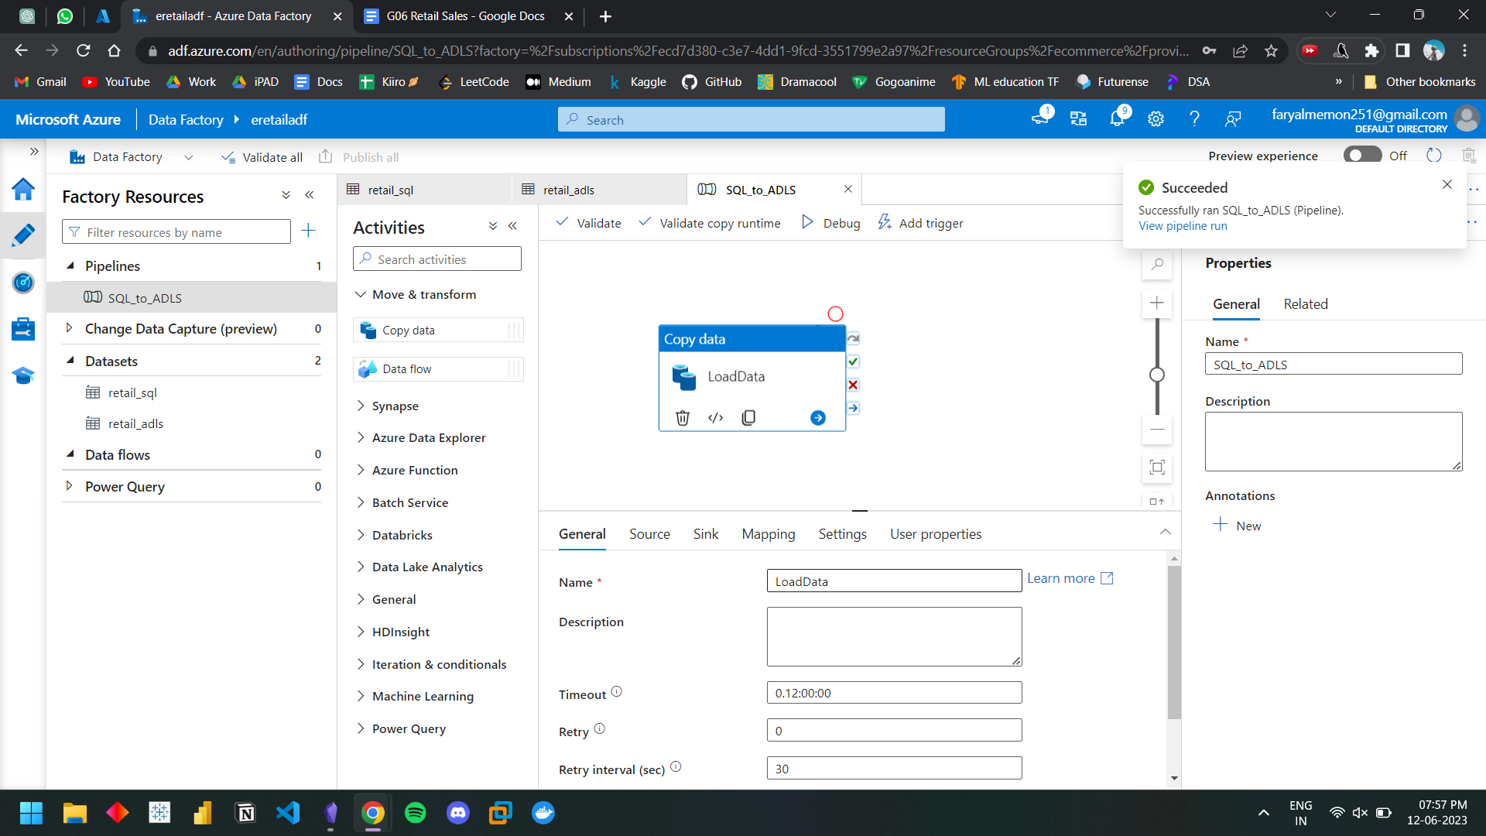

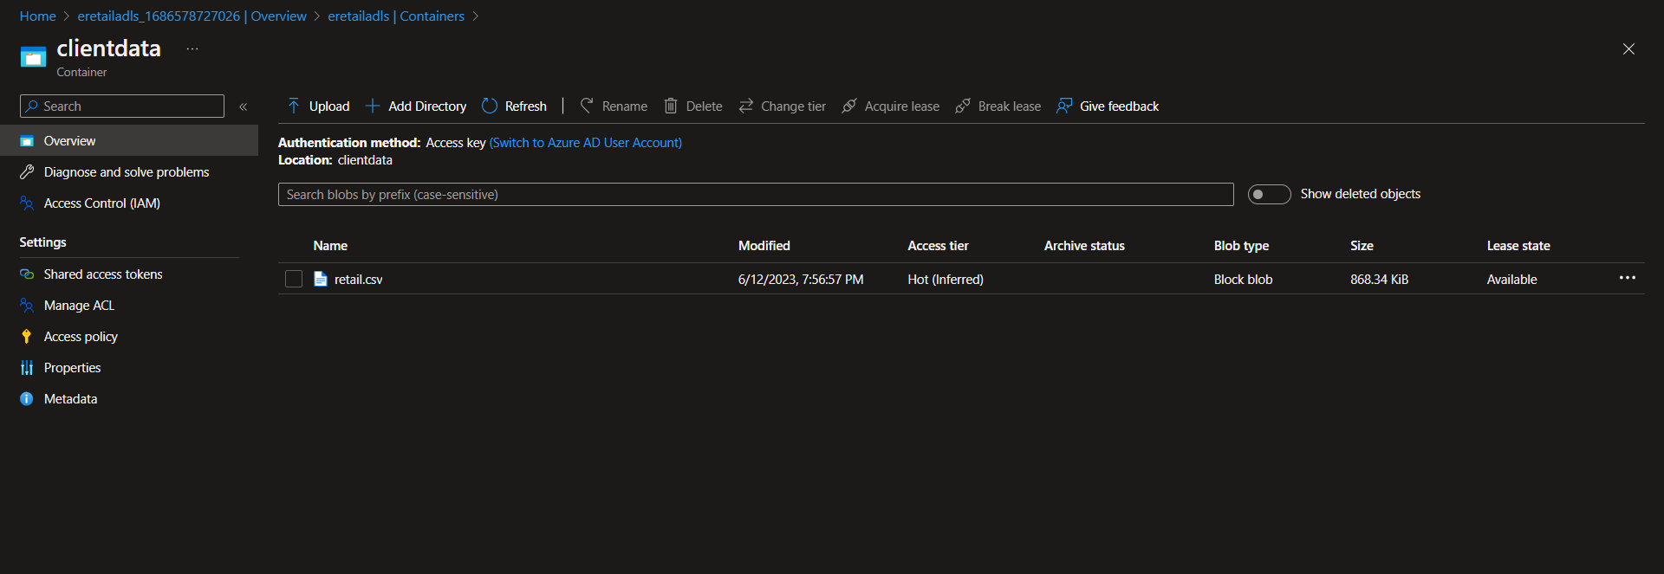

## 

## Analysis in Synapse Studio

### Create Spark Pool and give each user the appropriate permissions of the Synapse Workspace

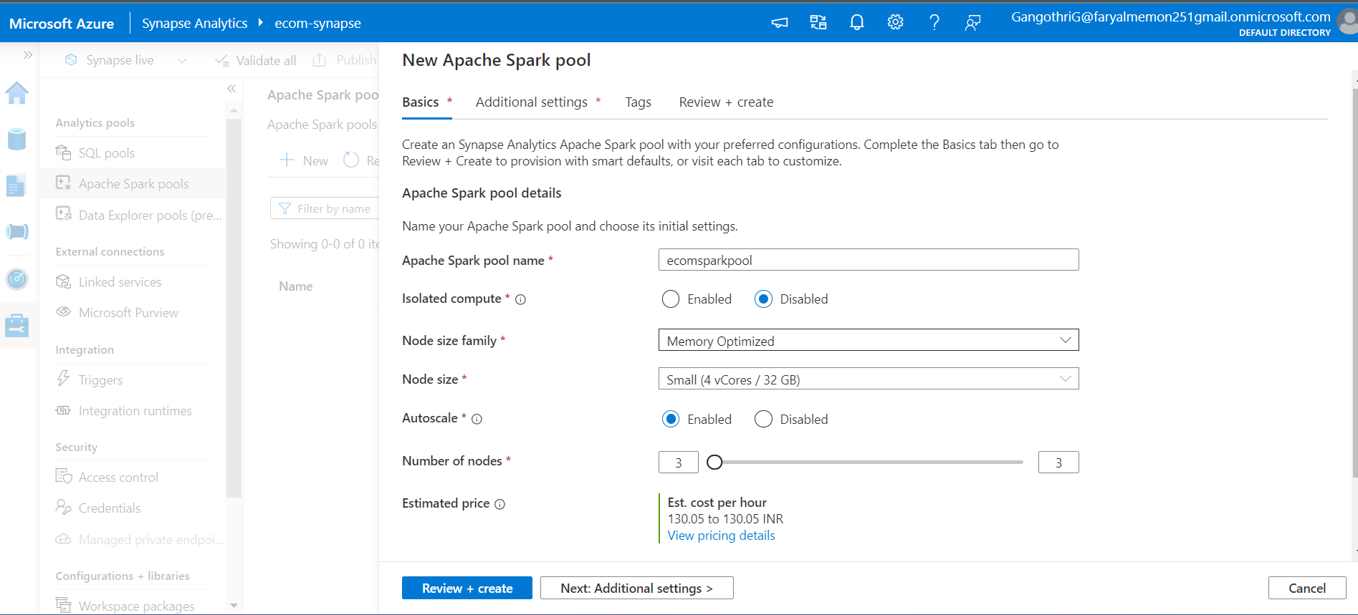

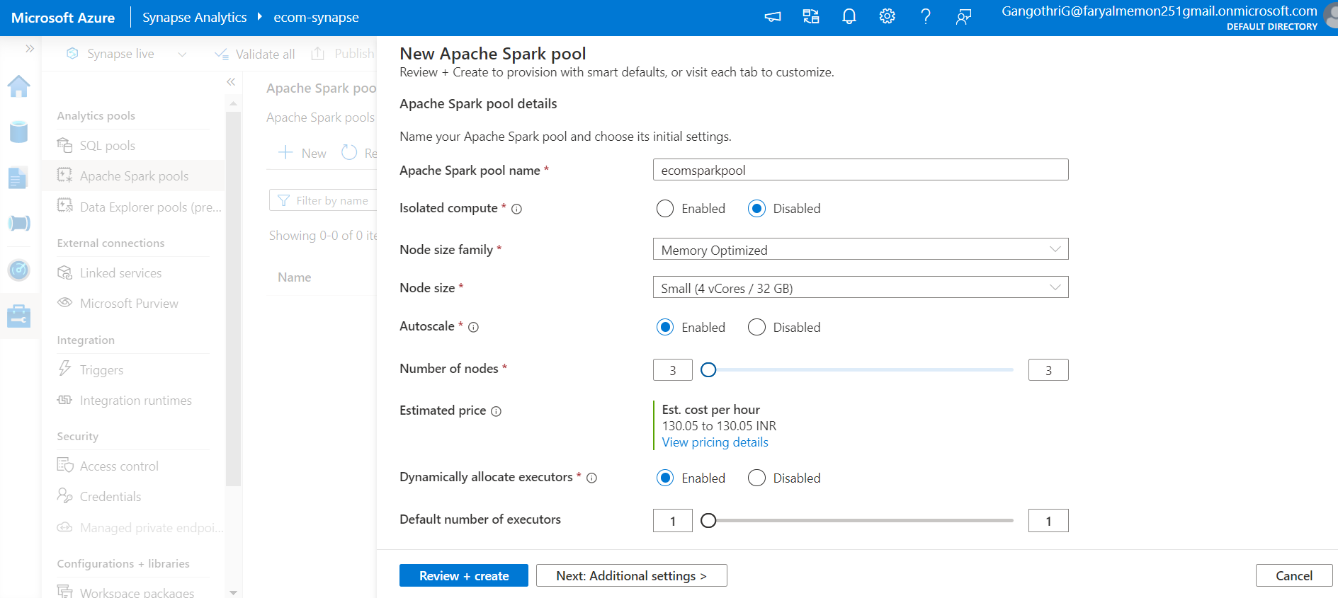

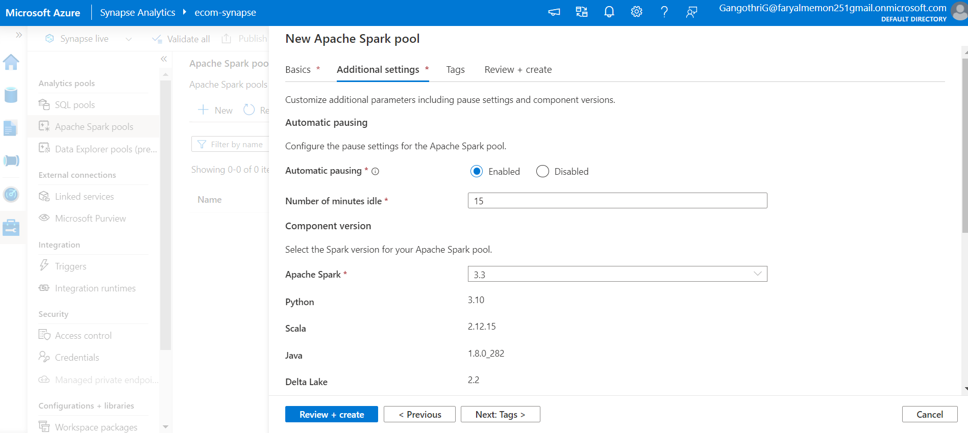

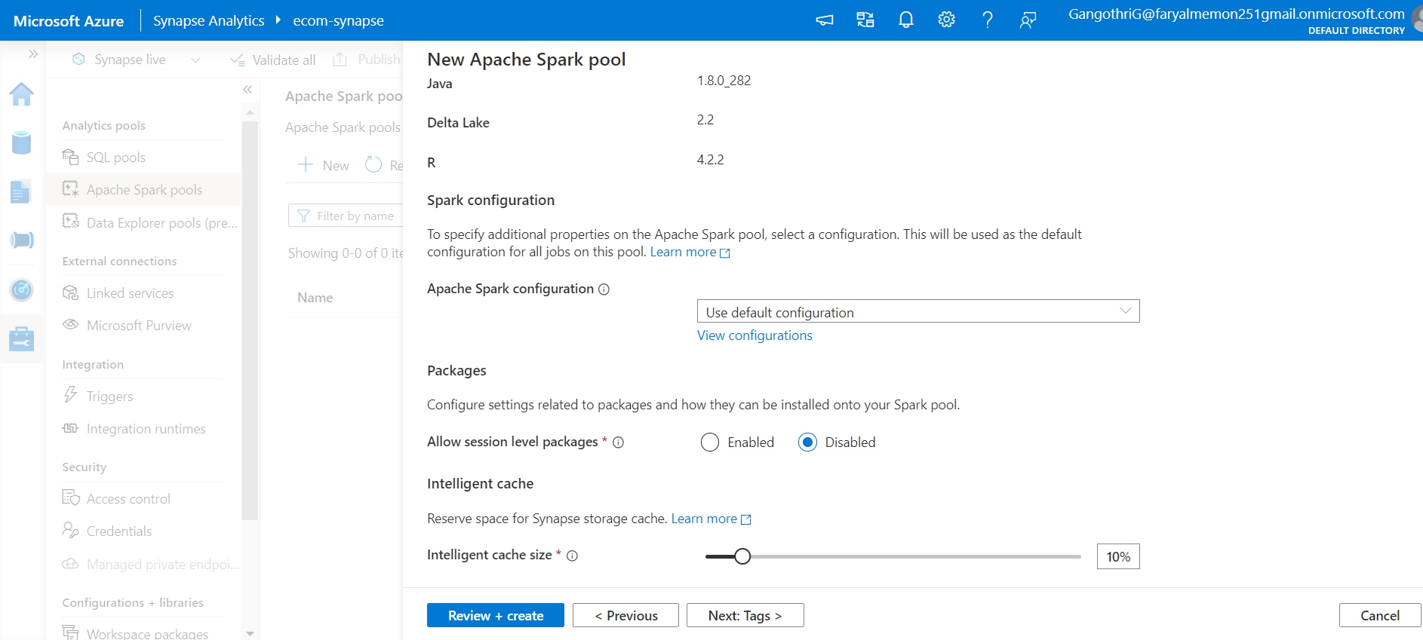

### Analyzing Queries

**# A.7.Display the number of sales year wise .(Using pyspark)**

from operator import add

year_and_revenue = rdd_df.map(lambda l: (l[5].year, l[11]))

yearly_sales = year_and_revenue.reduceByKey(add).sortBy(lambda x: x[0])

yearly_sales.collect()

**# A.8. Display the number of orders for each item.(Using pyspark)**

from operator import add

each_item = rdd_df.map(lambda l: (l[2], 1))

item_ocount = each_item.reduceByKey(add).sortBy(lambda x: x[1], ascending=False)

item_ocount.collect()

**# A.9. Display the country with highest sale (Using pyspark)**

from operator import add

country_order = rdd_df.map(lambda l: (l[1], l[11]))

country_revenue = country_order.reduceByKey(add).sortBy(lambda x: x[1], ascending=False)

country_revenue.take(10)

**# B.4 Yearly sum for specific country**

from operator import add

iyear = 2013

year_and_revenue = rdd_df.map(lambda l: (l[5].year, l[11]))

yearly_sales = year_and_revenue.reduceByKey(add).sortBy(lambda x: x[0])

yearly_sales.filter(lambda l: l[0]==iyear).map(lambda x: x[1]).first()

**# B.6. monthly sales report of a particular year**

from operator import add

iyear = 2014

each_month = rdd_df.map(lambda l: ((l[5].year, l[5].month), l[11]))

yearlymonth_sales = each_month.reduceByKey(add).sortBy(lambda x: x[0])

yearlymonth_sales.filter(lambda l: l[0][0]==iyear).map(lambda x: (x[0][1],x[1])).collect()

**# B. 7) Quarterly sales report of a particular year**

import math

def quarter(date):

return math.ceil(date.month/3)

iyear = 2014

each_quarterly = rdd_df.map(lambda l: ((l[5].year, quarter(l[5])), l[11]))

yearlyquarter_sales = each_quarterly.reduceByKey(add).sortBy(lambda x: x[0])

yearlyquarter_sales.filter(lambda l: l[0][0]==iyear).map(lambda x: (x[0][1], x[1])).collect()

**# B. 8, 11) For each quarter report for each year Write udf function for that. And for all year**

import math

def quarter(date):

return math.ceil(date.month/3)

each_quarter = rdd_df.map(lambda l: ((l[5].year, quarter(l[5])), l[11]))

yearquarter_sales = each_quarter.reduceByKey(add).sortBy(lambda x: x[0])

yearquarter_sales.collect()

**# B.15. Compare the quarterly sales of each country of the particular year.**

import math

def quarter(date):

return math.ceil(date.month/3)

iyear = 2014

country_quarterly = rdd_df.map(lambda l: ((l[5].year, l[1], quarter(l[5])), l[11]))

cyearlyquarter_sales = country_quarterly.reduceByKey(add).sortBy(lambda x: x[0])

cyearlyquarter_sales.filter(lambda l: l[0][0]==iyear).map(lambda x: ((x[0][1], x[0][2]), x[1])).take(20)

**Synapse:**

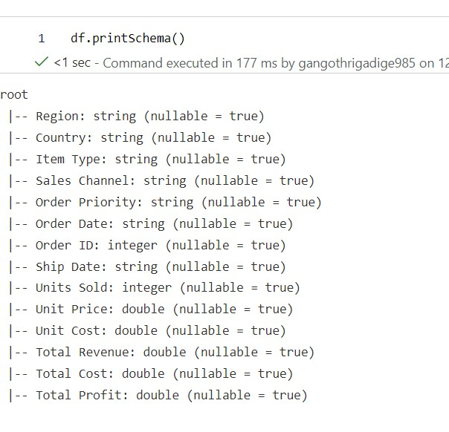

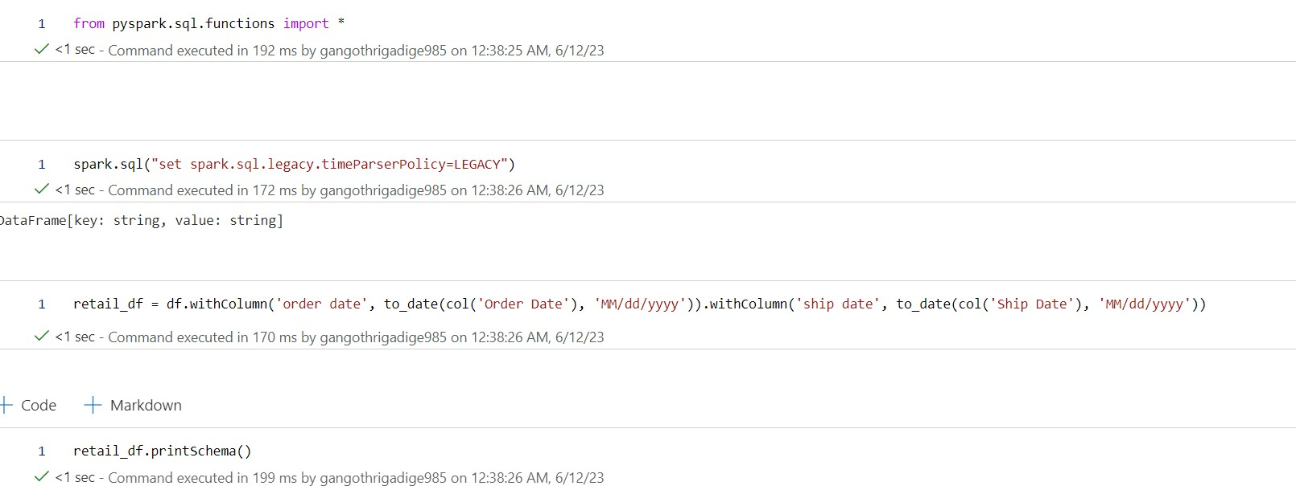

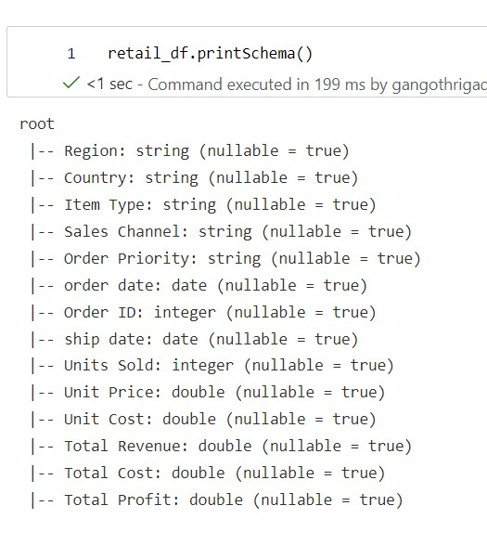

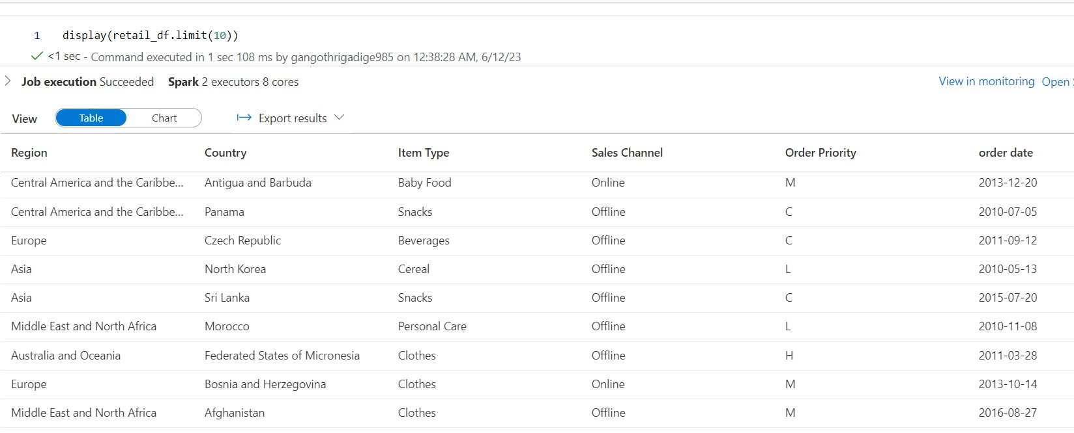

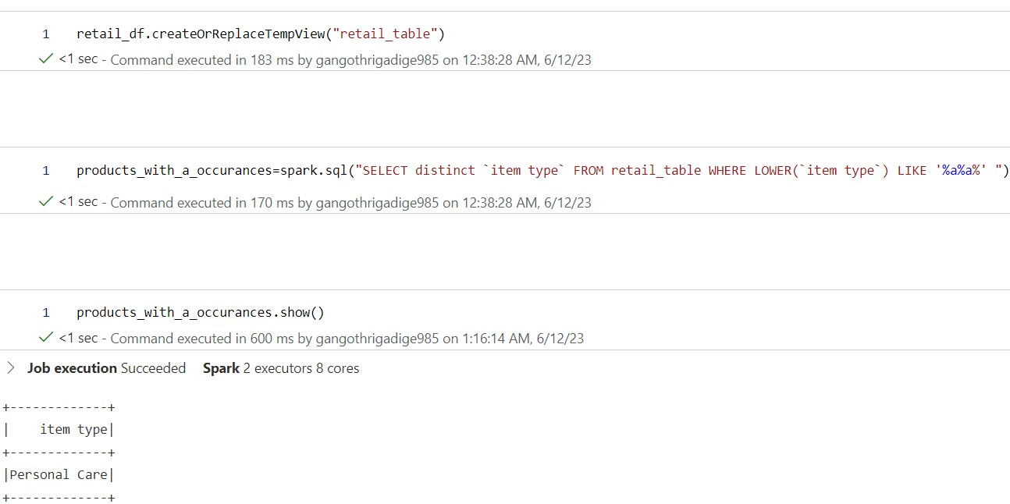

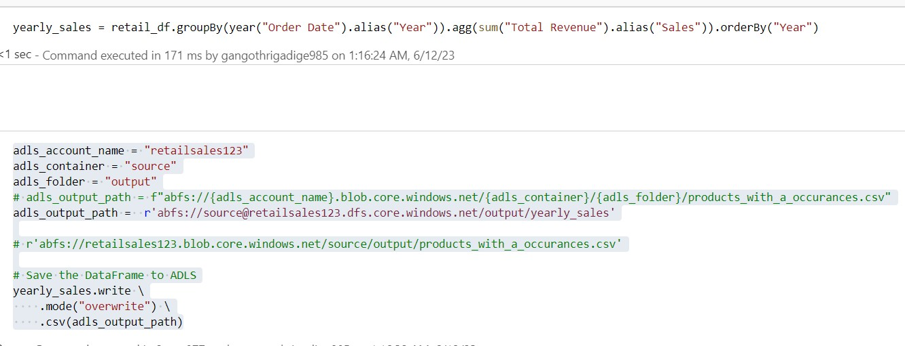

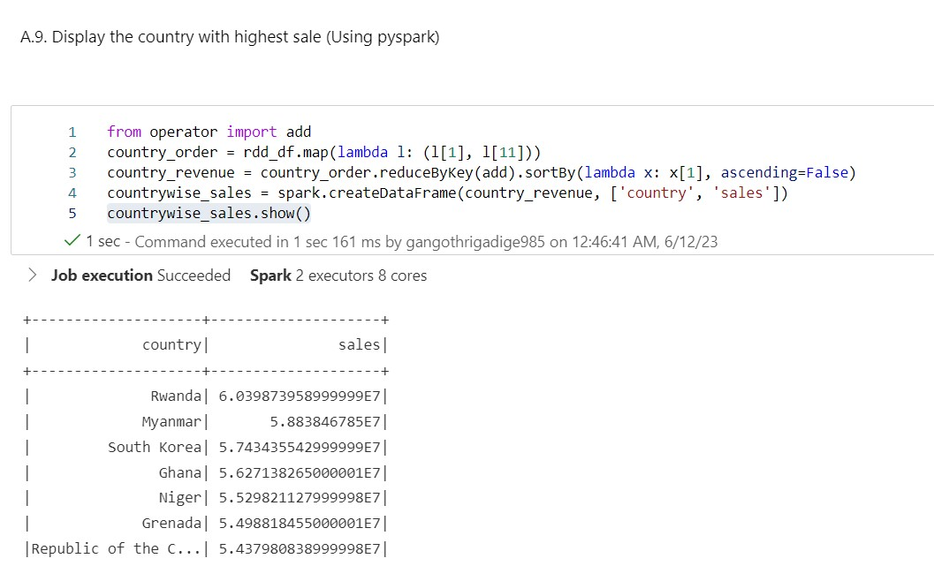

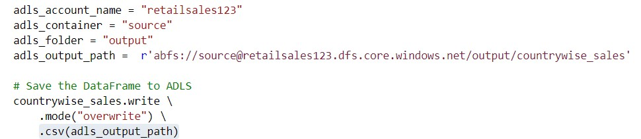

%%pyspark

df = spark.read.load('abfss://retaildb@ecomfiles1.dfs.core.windows.net/dbo.retail.csv', format='csv'

## If header exists uncomment line below

, header=True,inferSchema=True

)

display(df.limit(10))

from pyspark.sql.functions import *

spark.sql("set spark.sql.legacy.timeParserPolicy=LEGACY")

retail_df = df.withColumn('order_date', to_date(col('order_date'), 'MM/dd/yyyy')).withColumn('ship_date', to_date(col('ship_date'), 'MM/dd/yyyy'))

retail_df.printSchema()

root

|-- region: string (nullable = true)

|-- country: string (nullable = true)

|-- item_type: string (nullable = true)

|-- sales_channel: string (nullable = true)

|-- order_priority: string (nullable = true)

|-- order_date: date (nullable = true)

|-- order_id: integer (nullable = true)

|-- ship_date: date (nullable = true)

|-- units_sold: integer (nullable = true)

|-- unit_price: double (nullable = true)

|-- unit_cost: double (nullable = true)

|-- total_revenue: double (nullable = true)

|-- total_cost: double (nullable = true)

|-- total_profit: double (nullable = true)

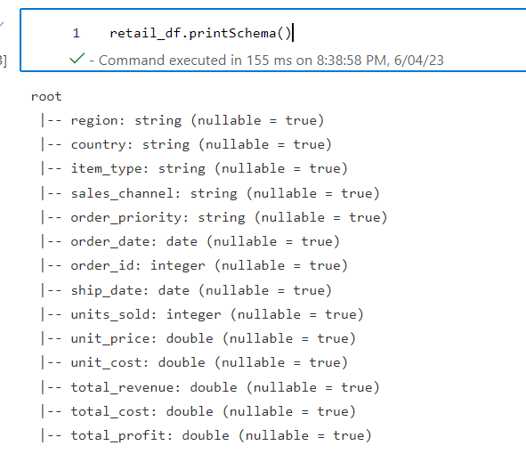

retail_df.createOrReplaceTempView("retail_table")

products_with_a_occurances=spark.sql("SELECT distinct item_type FROM retail_table WHERE LOWER(item_type) LIKE '%a%a%' ")

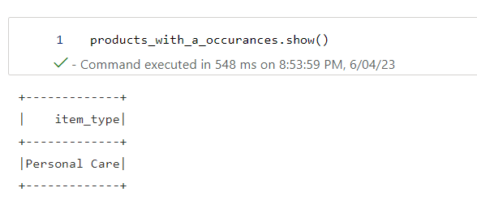

**Databricks**

